Fwd: File system management - Assignment

1) List out 5 files in your system which consuming most of the disk space
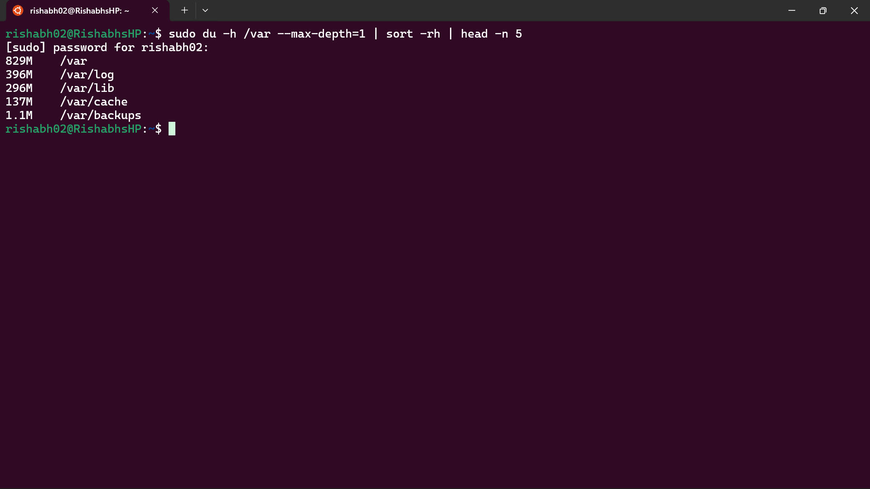

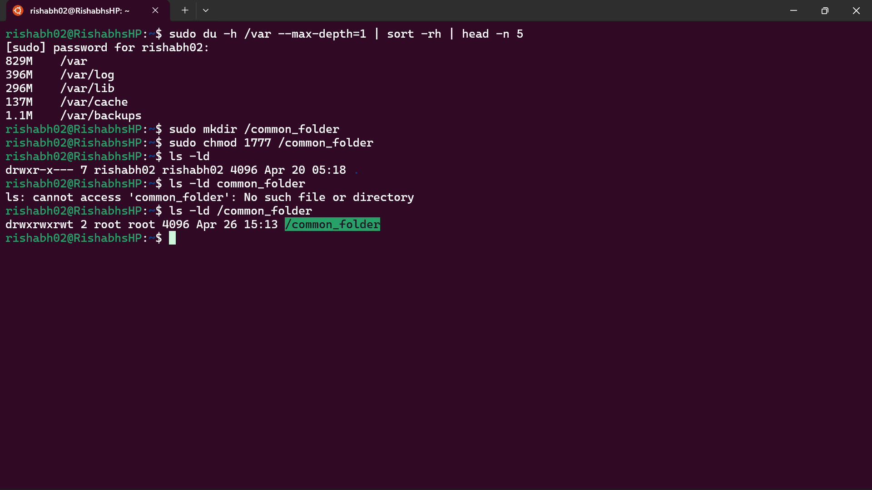
2) Create one common folder in such way that anyone can create files inside that independently and should not be able to delete other users files from that common folder.

3) Create user name "shubham" and add that user in the group "adm"
a) Create folder /data , change owner and group as "root:adm
b) Change /data permission such a way that user can able to write data in this folder and ownership of files or folder which you creates in this folder should be same as parent folder i.e /data folder permission (root:adm)

</>#
.. root adm /data

</data>#
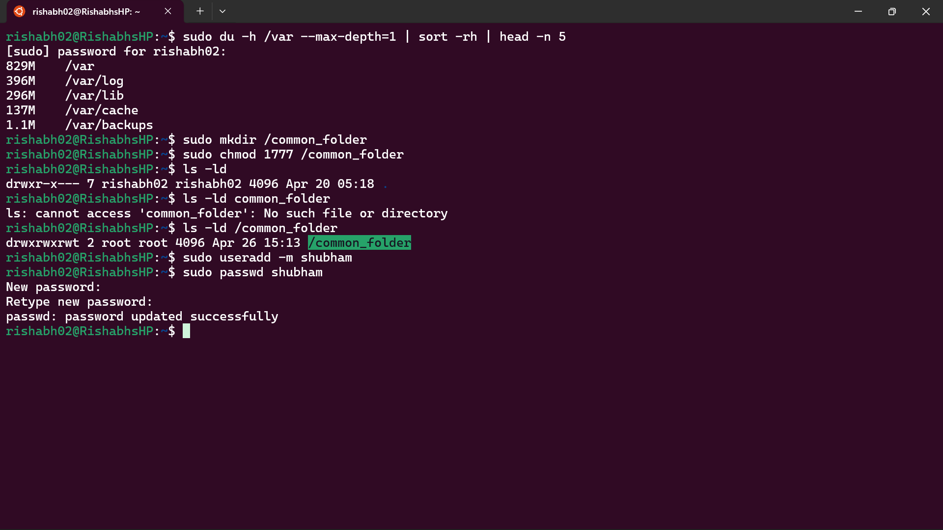
rw_rw_r root adm test.txt

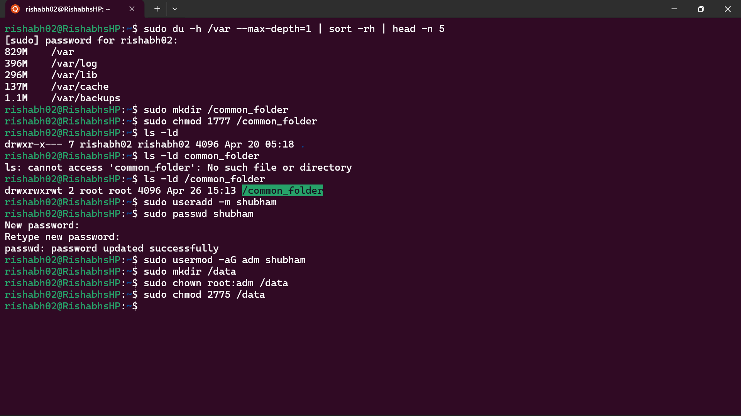

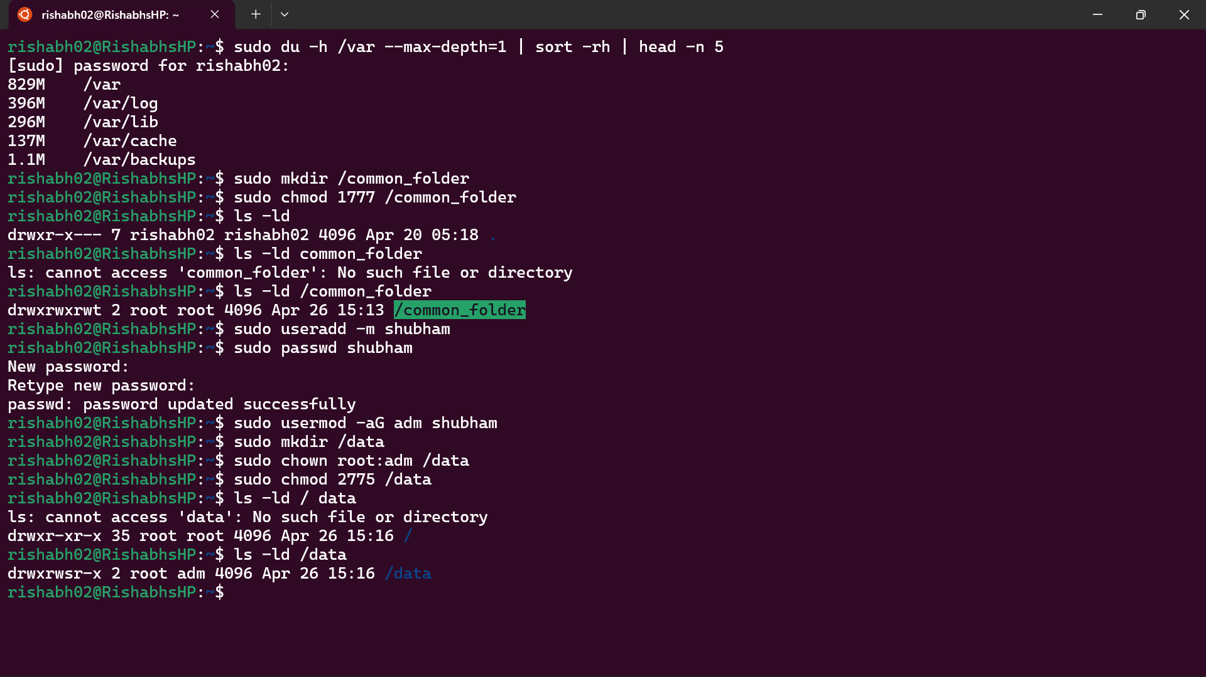

Explanation:-

1) List out 5 files consuming most disk space
Command:
sudo du -ah / 2>/dev/null | sort -rh | head -n 5
Explanation:
- du -ah shows size of all files and directories
- / means entire filesystem
- 2>/dev/null removes permission errors
- sort -rh sorts by size in descending order
- head -n 5 shows top 5 largest files

2) Create a common folder where users can create files but cannot delete others' files
Step 1: Create directory
sudo mkdir /common
Step 2: Set permissions
sudo chmod 1777 /common
Explanation:
- 777 allows all users to read, write, and execute
- 1 (sticky bit) ensures users cannot delete files of others
- Only file owner and root can delete their files

3) Create user "shubham" and configure /data directory

Step 1: Create user and add to adm group
sudo useradd -m shubham
sudo usermod -aG adm shubham
Explanation:
- -m creates home directory
- -aG adds user to adm group

Step 2: Create /data directory
sudo mkdir /data

Step 3: Change ownership to root:adm
sudo chown root:adm /data

Step 4: Set permissions and group inheritance
sudo chmod 2775 /data
Explanation:
- 2 sets SGID (Set Group ID)
- 775 gives:
  - owner (root) = read, write, execute
  - group (adm) = read, write, execute
  - others = read, execute
- SGID ensures:
  - all files created inside /data inherit group "adm"

Result
/data directory:
owner = root
group = adm
Files created inside /data:
- owner = user who created file
- group = adm (inherited from parent)
Example:
rw-rw-r-- shubham adm test.txt

